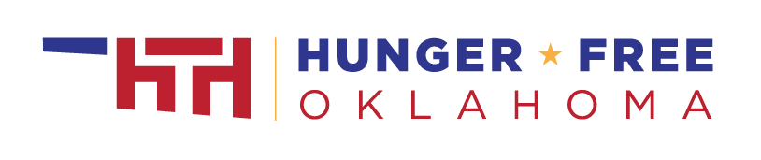
P-EBT Sample Facebook/Twitter Post:
Was your child approved to receive free or reduced-price school meals in the 2020-2021 school year? Pandemic EBT helps cover the cost of groceries due to your children missing in-person school meals during the pandemic. Learn more – www.hungerfreeok.org/pebt
P-EBT Sample Text Message:
P-EBT helps cover the cost of groceries for approved students who missed in-person meals during the pandemic. Get details here – www.hungerfreeok.org/pebt
P-EBT Robo Call Script 1:
Hello! This is [share Name/Title/Organization] calling about the Pandemic EBT program. If your student was approved for free or reduced-price school meals during the 2020-2021 school year you may be eligible for a Pandemic Electronic Benefits Transfer card, or P-EBT card. P-EBT helps your household replace the cost of meals that increased when children were not at school in-person. Eligible children can receive up to $6.82 per qualifying school day. To learn more, visit www-dot-hungerfree-o-k-dot-o-r-g-forward slash-p-e-b-t. Thank you!
P-EBT Robo Call Script 2:
Hello [school/organization name] families! This is [title, name] calling about the Pandemic EBT program. P-EBT is an important resource to help families who are struggling because of the pandemic. If your student was approved for the free or reduced-price school lunch program in the 2020-2021 school year, you could be eligible for grocery assistance of $6.82 per qualifying school day.
The Oklahoma Department of Human Services will be sending P-EBT benefits, or P-EBT, to eligible families – you do not need to apply. Please look out for a P-EBT card in the mail. Watch closely as the outside envelope may not clearly say P-EBT.
P-EBT will not impact your citizenship or immigration status.
To learn more, visit www-dot-hungerfree-o-k-dot-o-r-g-forward slash-p-e-b-t . Thank you!
P-EBT Sample App Message or Website Banner:
Was your child approved to receive free or reduced-price school meals in the 2020-2021 school year? Pandemic EBT helps cover the cost of groceries due to your children missing in-person school meals during the pandemic. Learn more – www.hungerfreeok.org/pebt
Email/Letter Template:
Subject Line: Pandemic Benefits Can Help You Buy Food
Body:
Hello [school/organization name] families!
We are writing to let you know about an important resource to help families who are struggling because of the pandemic. If your student was approved for free or reduced-price school lunch in the 2020-2021 school year, you could receive grocery assistance of $6.82 per eligible school day.
The Oklahoma Department of Human Services will be sending Pandemic Electronic Benefits Transfer benefits, or P-EBT, to eligible families – you do not need to apply. Please look out for a P-EBT card in the mail. Watch closely as the outside envelope may not clearly say P-EBT. If you haven’t received a card by October 15, 2021, please complete the form that will be available on this site: https://sde.ok.gov/pebt
P-EBT is provided to students who were approved for free or reduced-price school lunch in the 2020-2021 school year and were not able to eat meals at school due to the pandemic. It will not impact your citizenship or immigration status.
To learn more, visit www.hungerfreeok.org/pebt. Thank you!

